**Rakesh, Mohan (1925-1972)**

Mohan Rakesh was a leading twentieth-century Indian author whose drama, fiction, and criticism played a pivotal role in the Indian modernist movement after independence (1947– ), and whose work continues to exert a strong literary-artistic influence through the mediums of print as well as performance. He wrote primarily in Hindi, India’s majority language, but some critical essays were written originally in English, and his work in multiple genres has been translated widely into English as well as other major Indian and European languages since the 1960s. In relation to postcolonial and global modernisms, Rakesh exemplifies the cosmopolitan urban Indian writer whose authorial self-positioning responds carefully to the effects of British colonialism, European modernity, and the complex literary history of a major language such as Hindi.

Born in January 1925 in Amritsar (Punjab), Rakesh received a Bachelor’s degree in English and Master’s degrees in both Hindi and Sanskrit from Punjab University in Lahore (now in Pakistan). During the 1950s, he became closely associated with the *nai kahani* (‘new story’) movement in Hindi along with writers such as Rajendra Yadav, Mannu Bhandari, and Kamleshwar, publishing nine collections of stories between 1957 and 1968 and serving as editor of the literary magazine *Sarika* in the early 1960s. Rakesh’s first major novel, *Andhere band kamre* (Dark Sealed Rooms), appeared in 1961, followed by *Na anevala kal* (The Tomorrow that Never Arrives) in 1968 and *Antaral* (Interval) in 1972. In 1958, his first play, *Ashadh ka ek din* (One Day in the Season of Rain), marked a moment of radical departure in modern Hindi and Indian drama by portraying the classical Sanskrit poet-playwright Kalidasa—the symbol of Indian literary greatness—as a self-centered aesthete who is caught between the provincial sources of his poetic inspiration and the temptations of metropolitan patronage. This play earned Rakesh the Best Playwright award from the Sangeet Natak Akademi (India’s National Academy of Performing Arts) the following year. His second play, *Lahron ke rajhans* (Royal Swans of the Waves, 1963), also dealt with the matter of history, focusing on the Buddha’s younger brother Nand and his wife Sundari, while his last full-length play, *Adhe adhure* (Half-Done, Half-Unfinished, 1969), took up the postcolonial present to trace the collapse of the middle-class nuclear family in the punishing environment of the modern metropolis. Rakesh also published groundbreaking Hindi translations of two classical Sanskrit plays—Shudraka’s *Mrichchhakatika* (The Little Clay Cart) and Kalidasa’s *Shakuntala—*in 1961 and 1965, respectively.

In addition to his prolific output in drama and fiction, Rakesh was an active correspondent, diarist, memoirist, and essayist. At the time of his death in 1972, he was working on a theoretical study in English titled *The Dramatic Word*, and a steady stream of posthumous publications has made his letters, diaries, and uncollected critical writings available to readers.

**List of Works**

*Mohan Rakesh ke sampurna natak* (The Complete Plays of Mohan Rakesh). (1993) Ed. Nemichandra Jain, New Delhi: Rajpal.

*Mohan Rakesh ki sampurna kahaniyan* (The Complete Short Stories of Mohan Rakesh). (1996) New Delhi: Rajpal.

*Sahitya aur sanskriti* (Literature and Culture). (1990) New Delhi: Radhakrishna.

*Mohan Rakesh ki dayari* (The Diary of Mohan Rakesh). (1994) New Delhi: Rajpal.

*Natya-vimarsha* (Reflections on Theatre). (2003) Ed. Jaidev Taneja, New Delhi: National School of Drama.

*Ekatra* (Unpublished and Uncollected Works). (1998) Ed. Jaidev Taneja, New Delhi: Radhakrishna.

**References and Further Reading**

Dalmia, Vasudha. (2006) *Poetics, Plays, and Performances: The Politics of Modern Indian Theatre,* New Delhi: Oxford University Press.

Dharwadker, Aparna. (2008) ‘Mohan Rakesh, Modernism, and the Postcolonial Present’, *South Central Review* 25 (1): 136-62.

**-----.** (2005) *Theatres of Independence: Drama, Theory, and Urban Performance in India since 1947*, Iowa City: University of Iowa Press.

Mishra, Urmila. (1977) *Mohan Rakesh aur adhunikta* (Mohan Rakesh and Modernity). Varanasi: Vishwavidyalaya Prakashan.

Rakesh, Mohan. (1973) ‘Interview’, *Journal of South Asian Literature* 9 (2-3): 15-45.

**Aparna Dharwadker, University of Wisconsin–Madison**

**Recommended Illustrations**

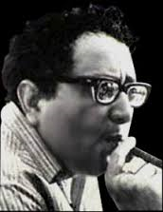

**Mohan Rakesh**

[Note from author about source/copyright/permission for this image: Photo from Google Images. This is the most frequently reproduced photo of Rakesh. If you want to use it, permission can be sought from his wife and executor, Anita Rakesh. She does not have an email address of her own, but can be contacted through her son, Sankalp, at [sankalp_sood@yahoo.com](mailto:sankalp_sood@yahoo.com). Her phone number is 011-91-11- 26314442.]

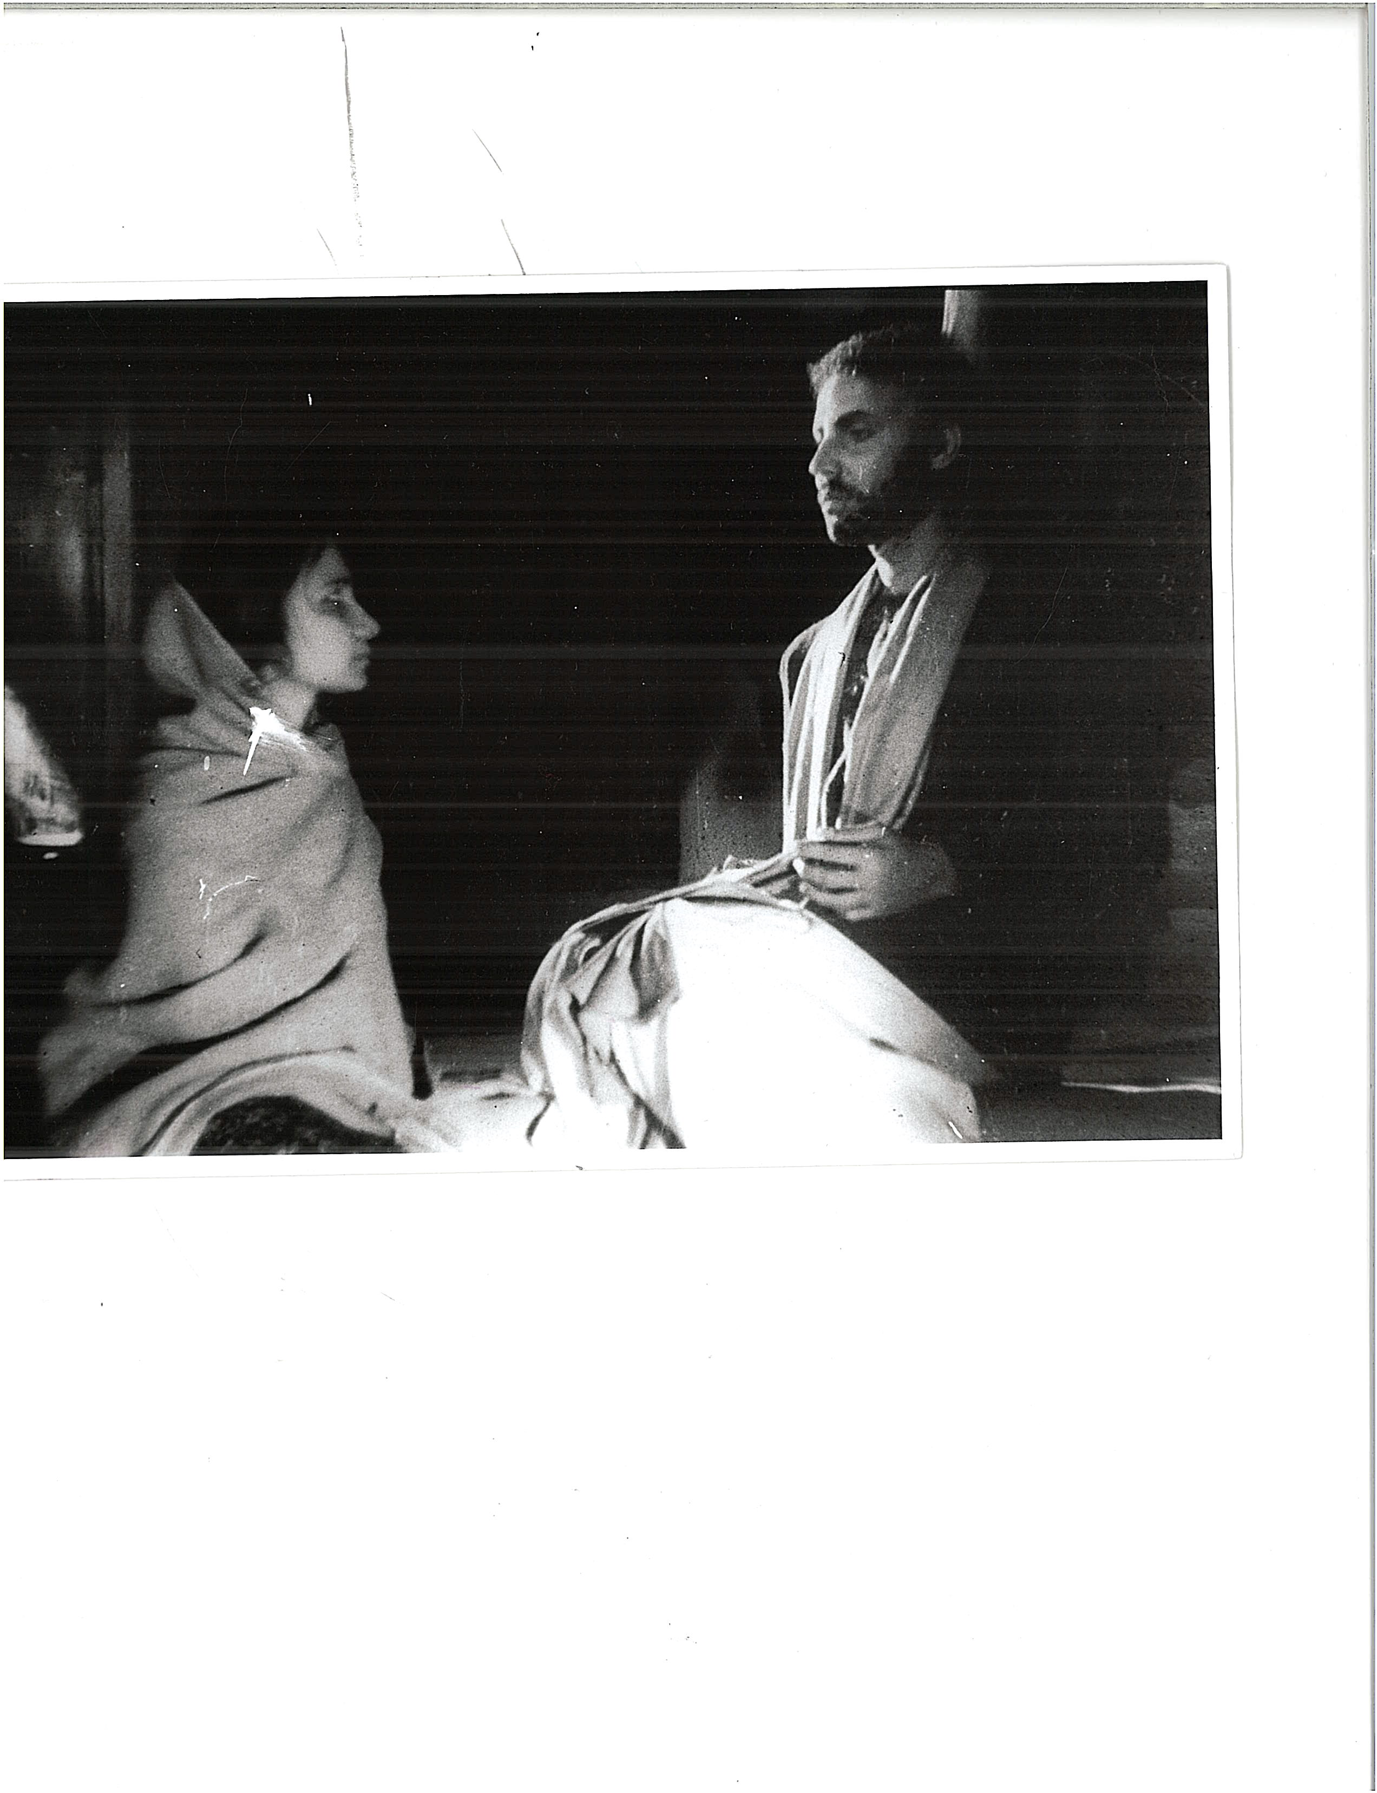

**Om Shivpuri as Kalidasa and Sudha Sharma (later Shivpuri) as Mallika in Ashadh ka ek din (One Day in the Season of Rain), directed by Ebrahim Alkazi, National School of Drama, New Delhi, 1962.**

[Note from author about source/copyright/permission for this image: Photo courtesy: NSD Repertory Company. This photo is reproduced on p. 237 of my book, Theatres of Independence. I had permission to use it then, but if permission is needed again, Routledge can contact the National School of Drama at 011-91-11-23389402, and ask to be connected to the office of the Repertory Company. They can refer to the permission I had received earlier, and request that to be extended.]

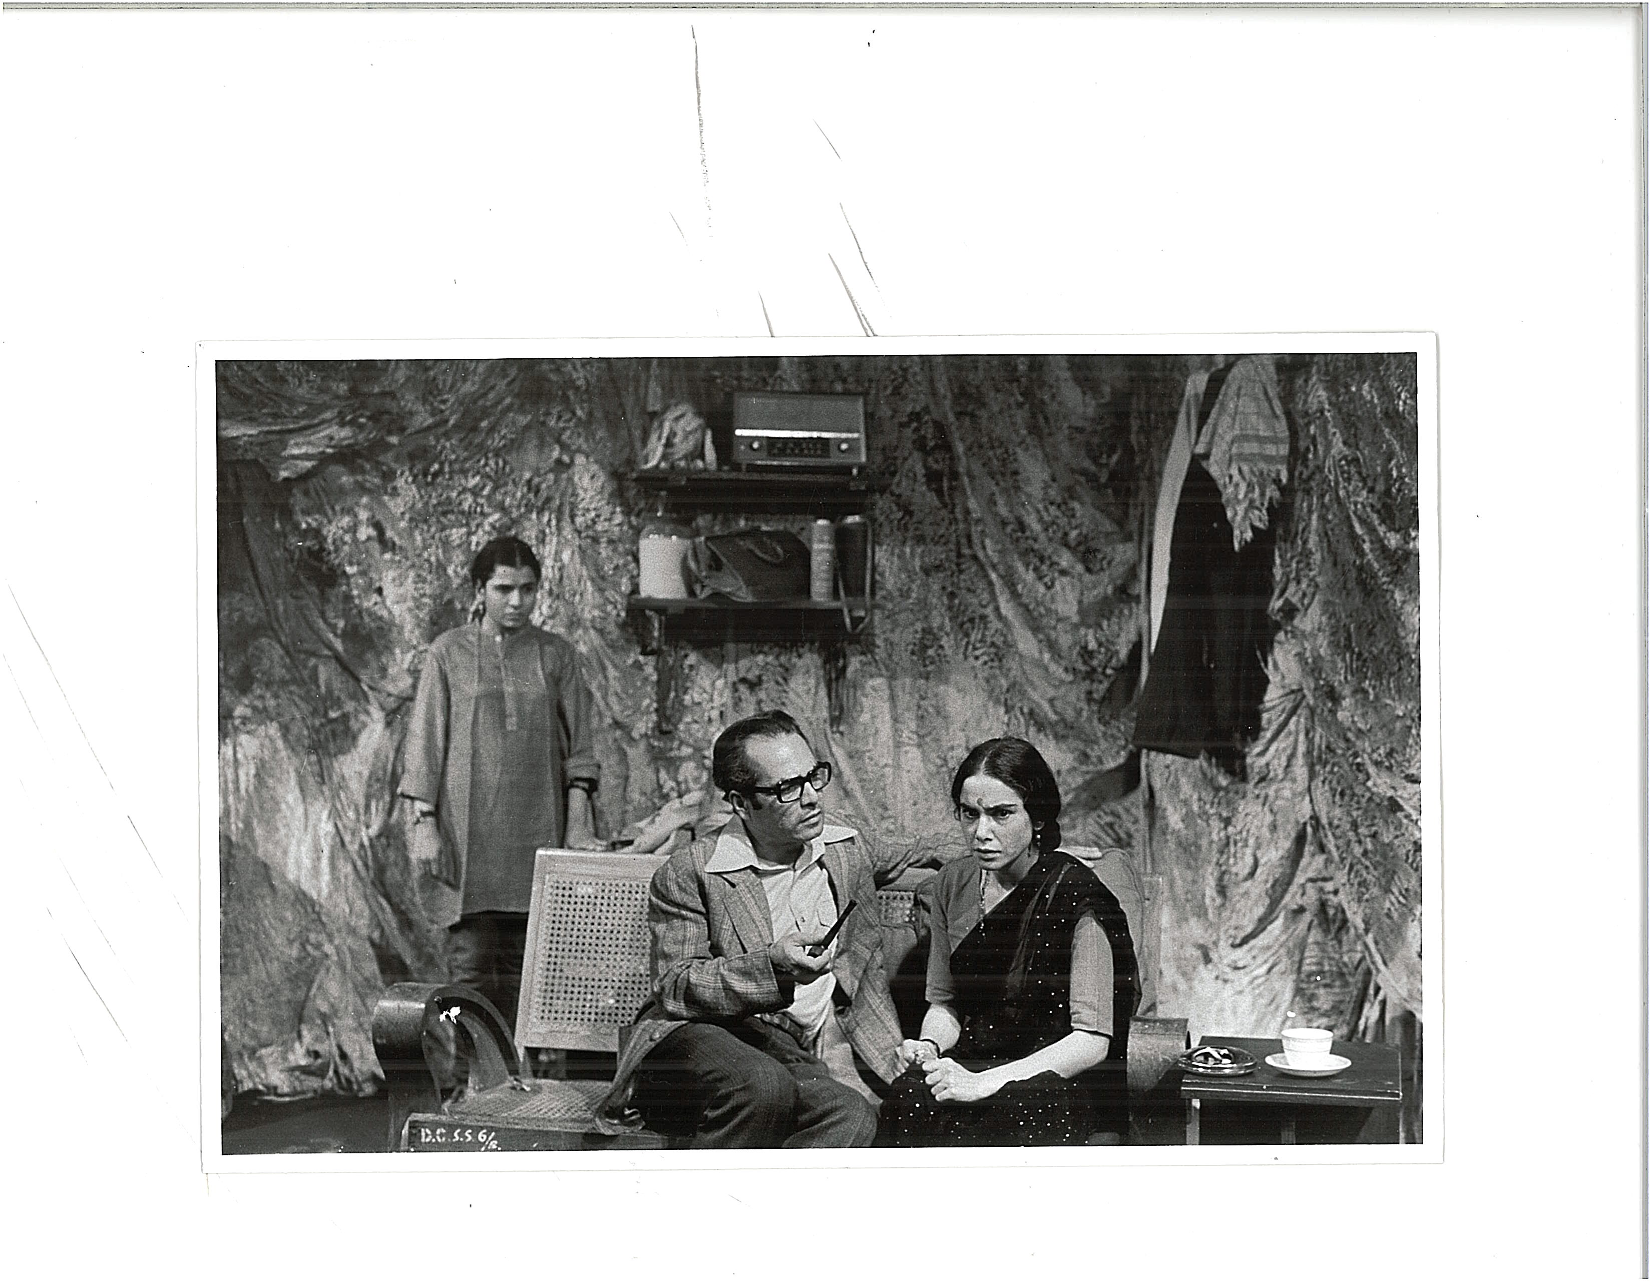

**Manohar Singh as Mahendranath, Surekha Sikri as Savitri, and Uttara Baokar as the Older Daughter in Adhe adhure (Half-Done, Half-Unfinished), directed by Amal Allana, National School of Drama Repertory Company, 1976.**

[Note from author about source/copyright/permission for this image: Photo Courtesy: NSD Repertory Company. Permission info same as above. This is also a photo I paid for back in 2003 or so, and the permission can be renewed.]